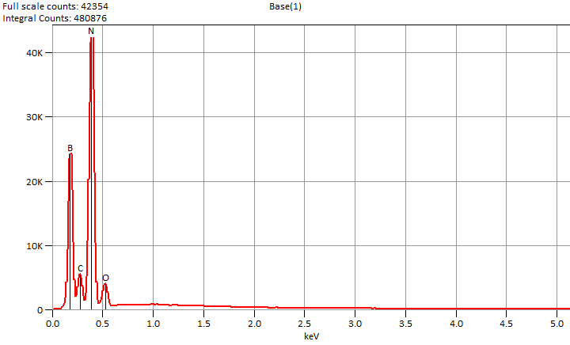

Live Time: 60.0 sec.

Mon Dec 02 11:45:55 2024

Filter Fit Chi Squared:190.789

Errors: +/- 1 Sigma

Correction Method: Proza (Phi-Rho-Z)

Acc.Voltage: 5.0 kV Take Off Angle: 34.7 deg.

Detector: UltraDry

WDS Results Unavailable for: Base(1)

|  |
| --- |
|  |

Quantitative Results for: Base(1)

|  |  |  |  |  |  |  |
| --- | --- | --- | --- | --- | --- | --- |
| ***Element***  ***Line*** | ***Int.***  ***Cps/nA*** | ***Int.***  ***Error*** | ***Weight %*** | ***Weight %***  ***Error*** | ***Atom %*** | ***Atom %***  ***Error*** |
| ***B K*** | 1996.6 | ± 21.31 | 19.7 | ± 0.2 | 24.2 | ± 0.3 |
| ***C K*** | 412.56 | ± 25.04 | 3.4 | ± 0.2 | 3.8 | ± 0.2 |
| ***N K*** | 3766.4 | ± 17.73 | 70.2 | ± 0.3 | 66.5 | ± 0.3 |
| ***O K*** | 249.38 | ± 8.23 | 6.7 | ± 0.2 | 5.5 | ± 0.2 |
| ***Total*** |  |  | 100.0 |  | 100.0 |  |

ROI Results for: Base(1)

|  |  |  |
| --- | --- | --- |
| ***Operation*** | ***Gross Counts*** | ***Net Counts*** |